3M
Home Learning Pack 3

Please take care and stay safe.

Miss Morgan

Dear 3M,

I hope that you are all taking care of yourselves and I’ll see you all soon.

On the school website, on the class page ‘3M’, I have set some work for the children to complete. This will change weekly, but I have still created the learning grids for some activities that the children might enjoy completing.

I know this is a stressful time for us all and I hope that all of you are safe and well. Also, I do not want the children and yourselves to be stressed and overworked with these home learning packs so please only complete one piece of work per lesson a day.

See you all soon and stay safe.

Miss Morgan

Mathematics
Please only complete one each week.
On the school website I have set the Mathematics work for 4 days a week with the link to the White Rose worksheets and videos to support the children. Please complete these and then choose one on the activities below for the Friday.
Times Tables
Spend at least 15 minutes a day practicing your times tables.
Mass and Capacity  Compare the weights of different objects. Which is heavier? | Mass and Capacity  Investigate how much water in ml you need to drink per day. | Length and perimeter  Measure how tall everyone is in your house in metres, centimetres and millimetres.
Place Value  Each of you choose a number and you need to guess it by asking numbers like ‘is it odd? Is it a 3-digit number? Does it have 3 tens or 1 ones (31)?’ | Shapes  On your walks or trips to the shop, record how many different shapes you can find. | Time  Create your own timetables for different days (at home, at school, on holiday etc).

English
Please only complete one each week with other lessons for planning, researching and re-drafting if you wish.
For the Summer Term 2 I had planned to read some Harry Potter with the children so I have planned some activities the children can complete. You can watch the video clips and read the books if you wish to support your child.
Read chapter 9 of Harry Potter and the Philosopher’s Stone or watch the scene https://www.youtube.com/watch?v=yTS1VlvlGRg  Please write descriptions of a broomstick lesson and ride. | Watch the clip  https://www.youtube.com/watch?v=CpXp1L7xB4o  Then please write a diary entry about what it would be like and how you would feel if you were there
Watch the clip  https://www.youtube.com/watch?v=1A6z7R-aaDw  You are now the Health and Safety inspector for the next Quidditch Match. So using the template provided in the pack labelled ‘Health and Safety Report’ Decide whether it was safe or not with a detailed explanation. | After watching the clip  https://www.youtube.com/watch?v=jbMg_R3nql0  You are now editor of the Daily prophet and you have been asked to write a newspaper report about what had happened in the clip. An example of a newspaper report has been provided in the pack.
Please write a setting description using the picture provided in the pack below. | You may write your own story. This can be about the stone age, the Titanic, Harry Potter or about something that you are interested in.

Topic, Science and Art
Investigate, if possible, which objects are magnetic in your house. | To sketch a map of somewhere you have been to or want to go to. | To complete a self- portrait using pencils or paints.
To investigate the speed of a toy car over different surfaces. Talk about friction and how this might impact on the speed of the car. Place toy car on a ramp (piece of card, book etc) with different materials that are smooth and rough. Which surfaces allows the car to move faster? | To complete the Jelly Cube Investigation. You will need Jelly cubes, chopsticks/lollypop sticks, some plates, vegetable oil. First set up a race between two people to move 6 jelly cubes from one plate to another using the  Chopsticks/lollypop sticks. Then, add some vegetable oil to the jelly cubes and see what happens. | To make your own Magnetic compass if you have some magnets. I have provided some instructions on how to make a Magnetic compass in the pack below.

Health and Safety Report
Name of inspector: | Date of inspection:
Overall rating of safety: /10
Will you allow the school to continue to play Quidditch?

Activity 3: Making a Magnetic Compass
You will need:
Method 1: Large dish/ bowl filled will water, large needle, cork, bar magnet or rare earth metal magnet e.g. neodymium (stronger magnets work better).
Method 2: Large clear plastic cup or glass jar, pencil, needle, thread, bar magnet or rare earth metal magnet e.g. neodymium (stronger magnets work better).
• Construct a floating compass or Chinese magnetic compass as shown on the following pages. You can display the larger images on the following pages on the board.
• Magnetize the needle by rubbing a bar magnet a dozen times along its length in one direction only. (A bit like the motion of brushing your hair).
• Explain to students that this rubbing action makes the needle magnetic.
• Bring the bar magnet close to (but not touching) the end of the needle and watch what happens to the needle.
• Then allow the needle to spin and come to rest on its own – note the direction in which the needle is pointing.

Chinese Magnetic Compass
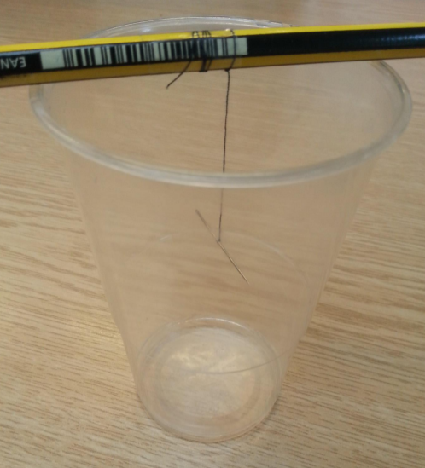
Floating Compass
