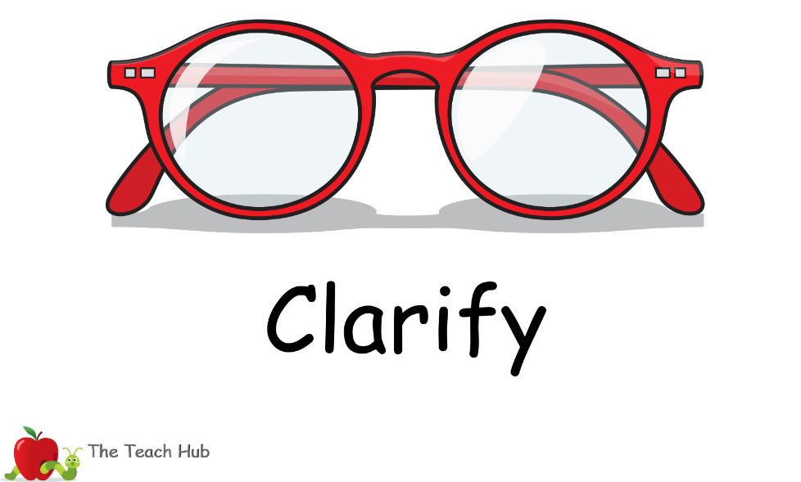  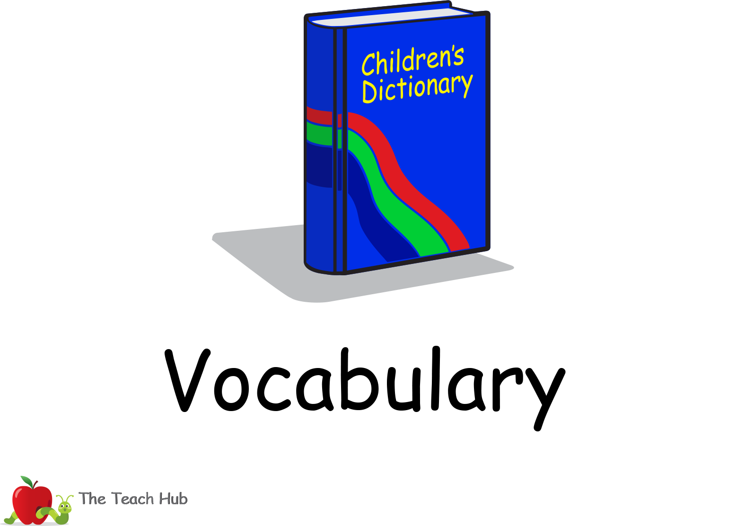  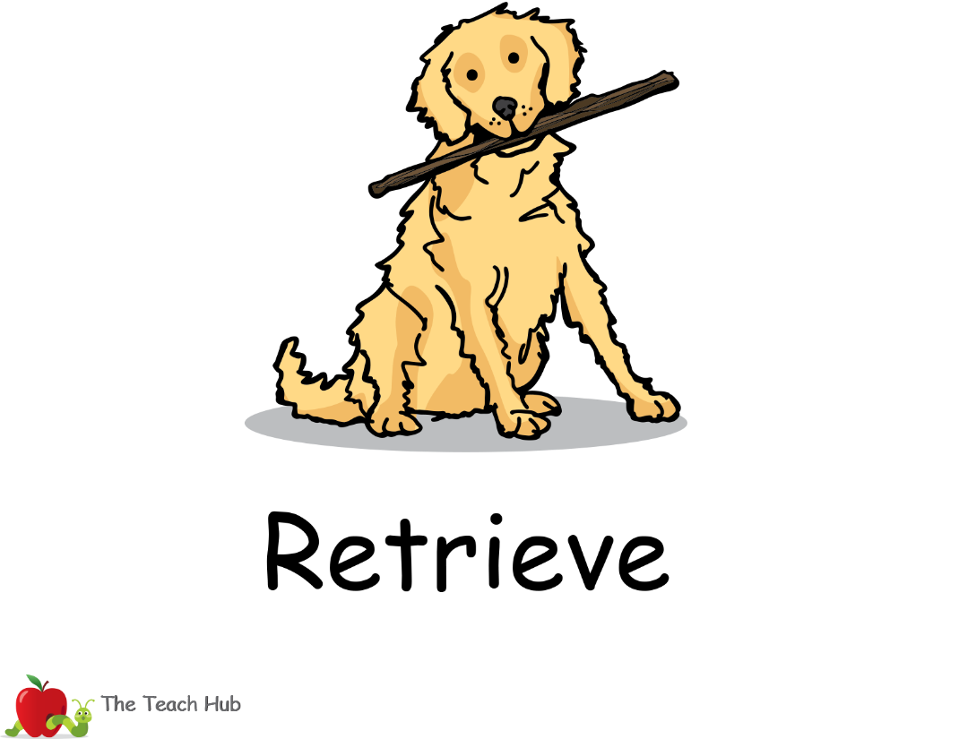  snoring, scared, woken, crocodile | 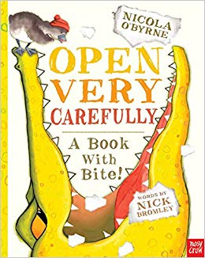

Narrative – Open Very Carefully. A Book with Bite!

- Find and copy one word that describes what the crocodile was doing when he was asleep.

- What colour was the crocodile’s new dance kit?

- How did Mr Crocodile get out of the book?

- Identify if this statements are true or false. | True √ | False X
The crocodile eats letters and words.

The story is about a crocodile who lives in a pond.

Mr Crocodile snapped and munched his way out of the book.
He loved his new bright blue dance kit.

Extension choice 1 – Use the new vocabulary in sentences of your own.
Extension choice 2 – Draw Mr Crocodile and label what he is wearing.

