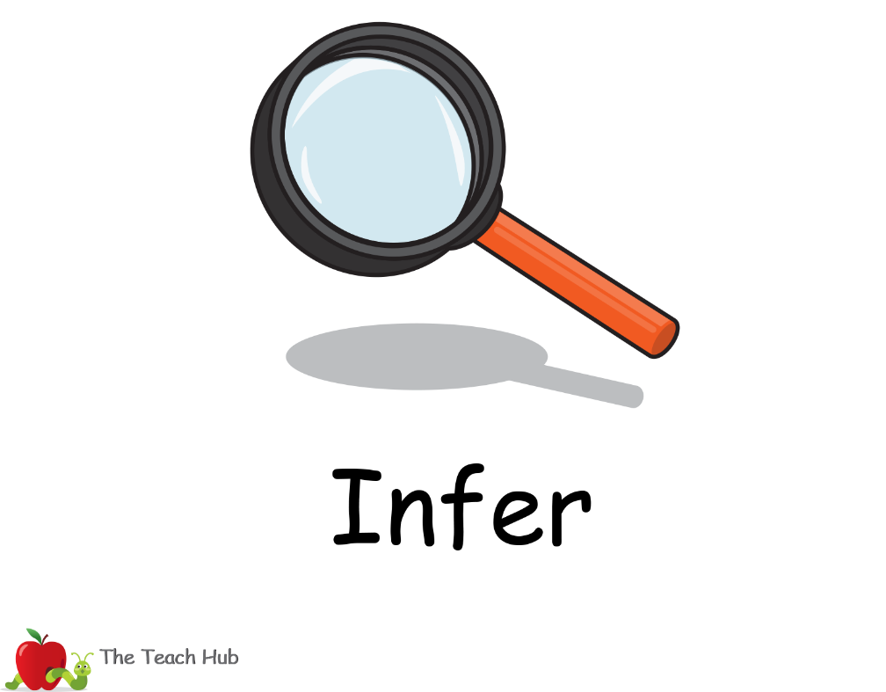  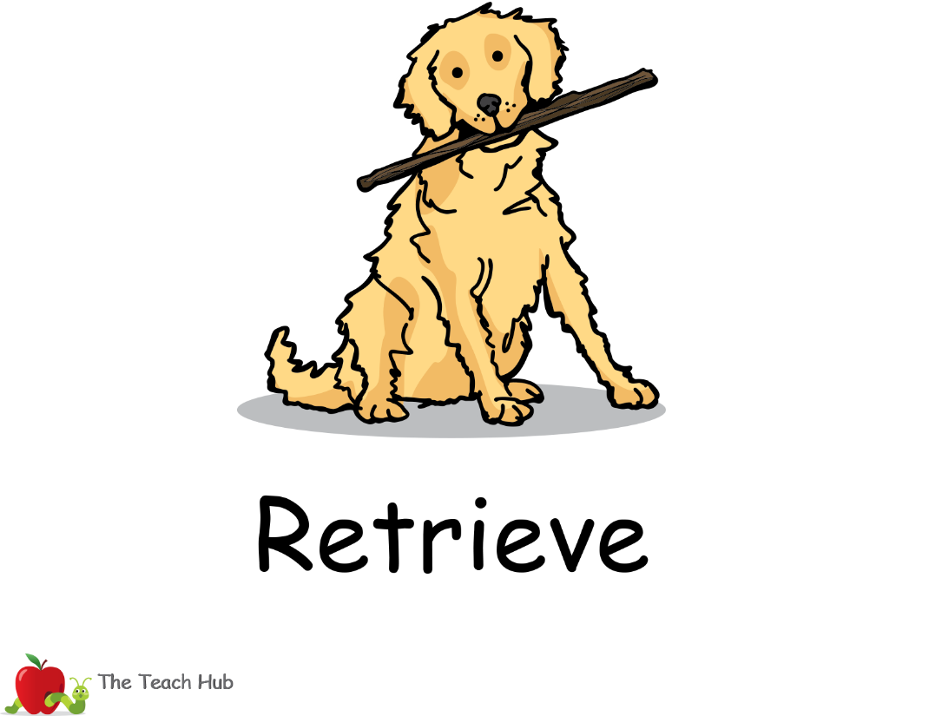  pond, ducklings, brave, scaly | 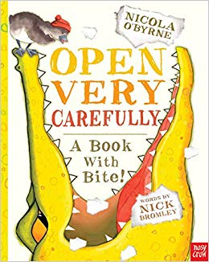
Narrative – Open Very Carefully. A Book with Bite!
- Why doesn’t Mr Crocodile belong in the story?
- What is the crocodile munching on?
- Draw and write sentences to show what you think will happen next in the story.

- Why doesn’t Mr Crocodile belong in the story?

- What is the crocodile munching on?
_________________________________________________________________________________________________________________________________________________________

3. Draw and write sentences to show what you think will happen next in the story.

Extension choice 1 – Use the new vocabulary in sentences of your own.
Extension choice 2 – Write about a book you like to read that has an animal in it and say why you like it.

